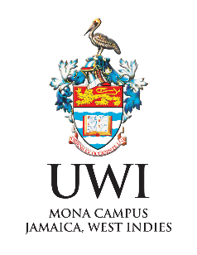



5TH MIXED METHODS CARIBBEAN REGIONAL CONFERENCE

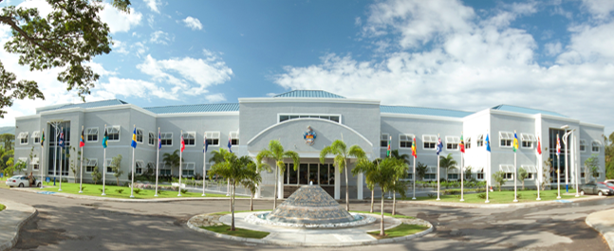

Conference Dates: Tuesday 15 – Wednesday 16 April, 2025
Location: Regional Headquarters, University of the West Indies, Kingston, Jamaica
Format: In-person
Theme: Advancing Mixed Methods Research: Bridging Cultures, Driving Transformation, and Fostering Innovation
Presentation Sub-Themes:
- Innovations in Technological Advancements for Mixed Methods Research: This theme explores how tools like AI, big data, and secondary data are transforming mixed methods research, with sessions on leveraging tech to enhance data collection, analysis, and integration.
- Diversity, Equity, and Inclusion (DEI) through Mixed Methods: Focused on advancing DEI goals, this theme highlights culturally responsive mixed methods research that elevates marginalized voices and promotes inclusion across diverse contexts.
- Transformation and Social Impact in Mixed Methods Research: This theme examines community-based and action research approaches in mixed methods that foster social justice and positive community impact, bridging research and real-world change.
- Discipline-Specific Innovations in Mixed Methods Research: Tailored to the needs of various fields, this theme showcases how mixed methods can address unique disciplinary challenges, with examples of innovative applications across disciplines.

Purpose statement: This Mixed Methods Conference is in the Caribbean region. The conference theme is Advancing Mixed Methods Research: Bridging Cultures, Driving Transformation, and Fostering Innovation. The conference aims to facilitate inclusiveness across cultures, disciplines and specializations, encourage transformative approaches and visionary discourse on the theoretical and practical evolution of mixed methods research as a tool for societal development. The conference will facilitate greater collaboration among members of the global mixed methods research communities and continue to build the community of mixed methods researchers in the Caribbean region. The conference will facilitate dialogues and insights regarding Mixed Methods among students, lecturers and non-academic professionals. The conference seeks to foster collaboration and develop a community of Mixed Methods Researchers in the Caribbean region. The mission of the Association is to engage with the international community to support mixed methods research, which broadly includes the following: mixing/combining/integrating quantitative and/or qualitative methods, epistemologies, axiologies, and stakeholder perspectives and standpoints

Conference Presentation Formats:
Paper session: - A paper session is a seminar that allows three individual authors or groups of authors to orally present their research and/or theoretical paper findings in no more than 20 minutes. At the end of the three presentations, 20 minutes are reserved for open discussions between the presenters and the audience.
Poster: - A research poster is a graphical summary of a research proposal or completed project by an individual or a group of researchers. Posters will be displayed on portable walls in the conference venue and should measure 36”x 24” in portrait orientation. Presenters will stand adjacent to their posters during poster sessions to answer questions from the audience. Individual presenters are limited to presenting ONE poster. Presenters may provide a 2-page research summary for the audience to take away.
Workshop: - A workshop is a self-organised seminar that engages participants in considerable interactive activities and discussions related to the conference theme. Workshops are 90 minutes and will accommodate up to 30 participants. Workshop facilitators must make their own arrangements for providing the necessary learning materials and resources for the session. Workshop proposers should submit a 500-word abstract that includes the workshop title, a description of the content, how it will be delivered and what participants are expected to gain. Include a list of technical equipment you will provide and others you may need from conference organisers.
Doctoral Mentorship Round Table: - The purpose of these mentorship sessions is to facilitate small groups of doctoral candidates meeting with and learning from leaders in mixed methods research. Round tables are reserved for doctoral students. Each round table will accommodate three students who will each have 20 minutes with mixed methods experts (5 minutes to share their methodology and 15 minutes for feedback). Abstracts should outline the topic of the research, research questions, and methodology.

Guidelines for Preparing Abstracts
Abstracts that align with the conference theme are invited from individuals and collaborative groups in any discipline who are interested in and engage in empirical mixed methods research and conceptual/theoretical papers with a focus on integration. Abstracts should be no more than 300 words and may be submitted by individual researchers or research groups. Individuals are limited to TWO presentations, including works-in-progress.
Abstracts must be formatted as follows:
- Title (no more than 15 words)
- Sub-theme: select the one that applies
- Background: description of the problem
- Purpose: research objectives, research question(s) and/or hypotheses
- Design and Methods (where applicable): research design, sampling strategy, description of participants, data collection procedures and instruments, data analysis approaches
- Findings (if available): summary of specific results
- Conclusions and Implications: main outcome(s) of the research (if available), implications for practice, policy or further research
- Keywords: (up to 5)
- Presentation Format: select from paper, round table, poster, workshop
Guidelines for Abstract Submission
Abstracts should be submitted via the Google form for double-blind peer review here: https://forms.gle/BvGQrbghpoYviqY17
The submission must include the name, affiliate organisation and country, and email address of the corresponding author, as well as names of co-authors. The decision about abstract acceptance will be communicated to the corresponding author via email.
Please note:
- Corresponding authors must submit abstracts in the online submission form. All correspondence relating to submissions will be communicated to corresponding authors for dissemination to authors and presenters.
- Abstracts for works-in-progress should indicate the expected results and a timeframe within which the work should be completed. Authors will be allowed to update abstracts within a reasonable time for inclusion in the conference programme, otherwise, they will be published as is.
- Submitting abstracts to this conference indicates that authors have read, understood and will comply with the Terms and Conditions outlined in the abstract submission portal.
- Corresponding authors will be notified of the acceptance decision via email by Monday 10th February 2025. Ensure that contact details are accurate.
- Due to the number of submissions, authors may not get their first choice of presentation format; conference organisers will communicate with authors in that case.
- Presenters are expected to go to the presentation room 15 minutes before the session begins.
- Presenters will be provided with the use of a computer, multimedia projector and screen.
- Authors of successful abstracts are recommended to submit their PowerPoint presentations or poster PDF to the conference organisers by Friday 11th April 2025.
Opportunity for Publication of Papers
Submitted abstracts accepted via the double-blind review process will be published in the conference programme. Authors of select papers will be invited to submit a full paper for peer-review consideration for publication in the Caribbean Journal of Mixed Methods Research (CJMMR). The deadline for these selected papers will be communicated to the authors.

IMPORTANT DATES
Call for Abstracts – Monday 11th November 2024
Abstract submission – Friday 10th January 2025
Acceptance Notification – Monday 10th February 2025

ABSTRACT SUBMISSION
Upload your completed abstracts (see guidelines for preparation) to: https://forms.gle/BvGQrbghpoYviqY17

